**Web Mining (CSE3024)**

**Lab Assignment 4**

Name: **Kritika Mishra**

Registration Number: **16BCI0041**

Slot: L15+L16

Date: 29th August 2018

Question:

**Write a python program to perform the following encoding for the ODD numbers between 1 – 30**

**i) Elias Gamma**

**ii) Elias Delta**

**iii) Golomb (b = 10)**

**Code:**

#!/usr/bin/python

from math import log,ceil

log2 = lambda x: log(x,2)

def binary(x,l=1):

    fmt = '{0:0%db}' % l

    return fmt.format(x)

def unary(x):

    return x*'1'+'0'

def elias_generic(lencoding, x):

    if x == 0: return '0'

    l = 1+int(log2(x))

    a = x - 2**(int(log2(x)))

    k = int(log2(x))

    return lencoding(l) + binary(a,k)

def golomb(b, x):

    q = int((x) / b)

    r = int((x) % b)

    l = int(ceil(log2(b)))

    #print q,r,l

    return unary(q) + binary(r, l)

def elias_gamma(x):

    return elias_generic(unary, x)

def elias_delta(x):

    return elias_generic(elias_gamma,x)

print(" i: Elias Gamma: Elias Delta: Golomb")

for i in range(31):

if(i%2!=0):

print("%5d: %-10s : %-10s : %-10s" %(i, elias_gamma(i),elias_delta(i), golomb(10,i)))

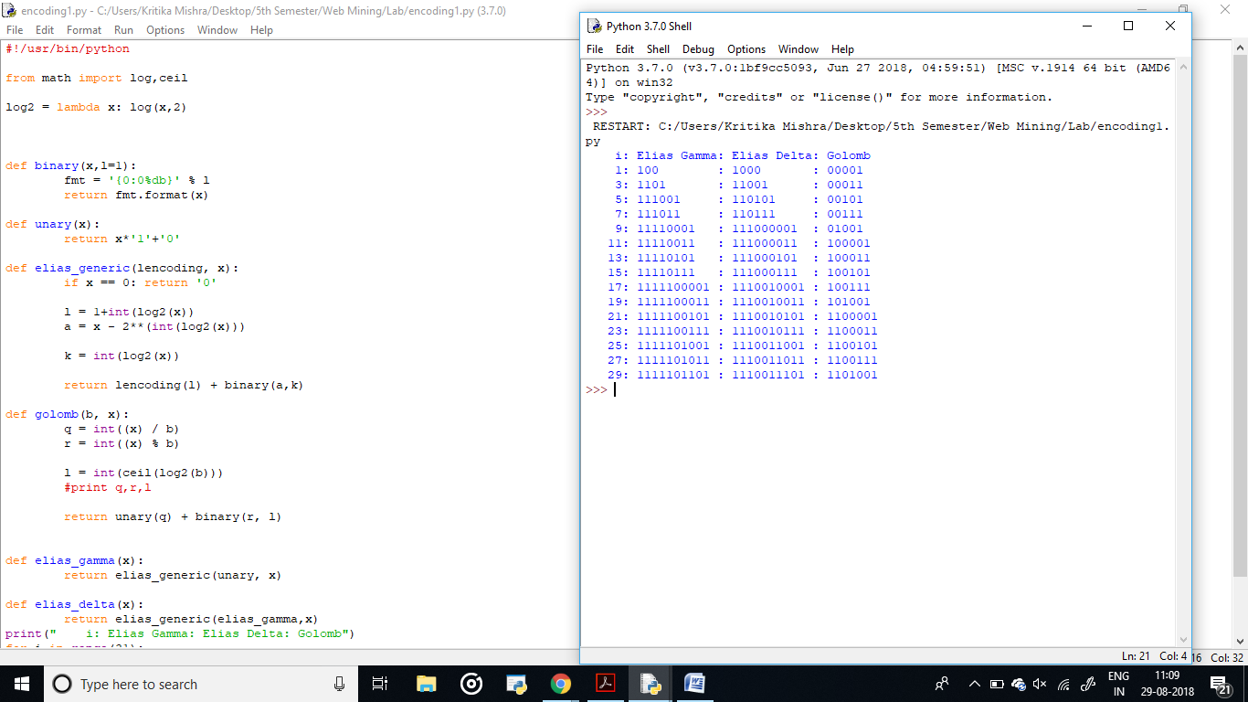

**Output:**

